Session 3 – lab Experiments
Ch. Bhargav Ram
192425334
06-10-26
Exp 4:
Program: Output
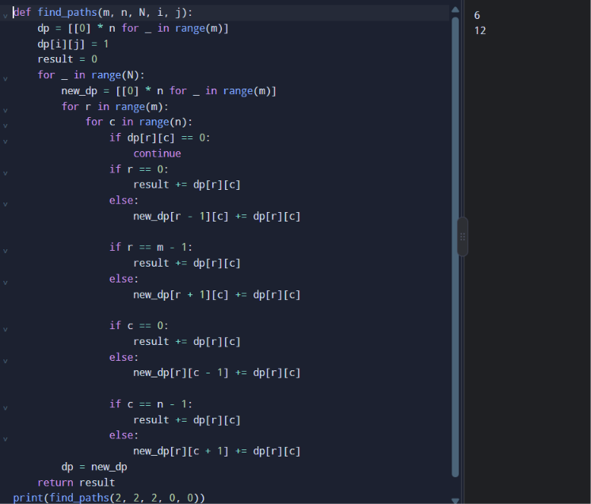

Exp 5:
Program: Output
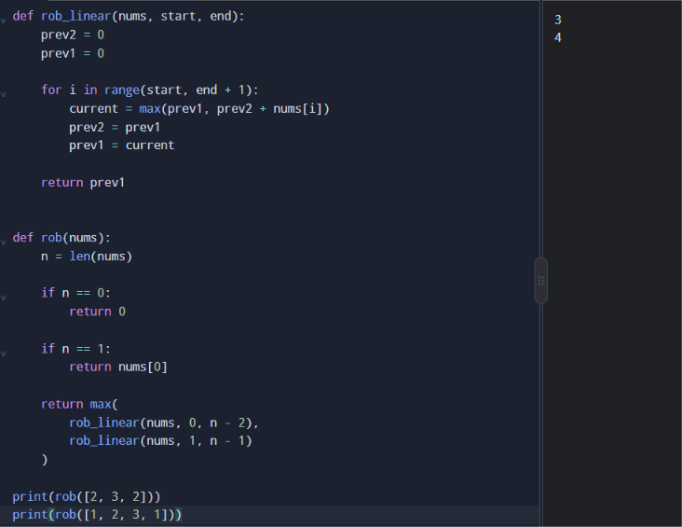
Exp 6:
Program: Output
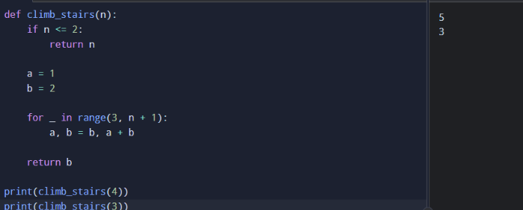
Exp 7:
Program: Output
